Semester One Examination, 2021

Question/Answer booklet

MATHEMATICS  
METHODS  
UNIT 1

**SOLUTIONS**

Section Two:  
Calculator-assumed

Student’s name

|  |  |
| --- | --- |
| Number of additional answer booklets used (if applicable): |  |

## Time allowed for this section

Reading time before commencing work: ten minutes

Working time: one hundred minutes

## Materials required/recommended for this section

***To be provided by the supervisor***

This Question/Answer booklet

Formula sheet (retained from Section One)

***To be provided by the candidate***

Standard items: pens (blue/black preferred), pencils (including coloured), sharpener,  
correction fluid/tape, eraser, ruler, highlighters

Special items: drawing instruments, templates, notes on two unfolded sheets of A4 paper, and up to three calculators, which can include scientific, graphic and Computer Algebra System (CAS) calculators, are permitted in this ATAR course examination

## Important note to candidates

No other items may be taken into the examination room. It is **your** responsibility to ensure that you do not have any unauthorised material. If you have any unauthorised material with you, hand it to the supervisor **before** reading any further.

## Structure of this paper

|  |  |  |  |  |  |
| --- | --- | --- | --- | --- | --- |
| Section | Number of questions available | Number of questions to be answered | Working time (minutes) | Marks available | Percentage of examination |
| Section One: Calculator-free | 8 | 8 | 50 | 52 | 35 |
| Section Two: Calculator-assumed | 15 | 15 | 100 | 98 | 65 |
|  | | |  | **Total** | 100 |

## Instructions to candidates

1. The rules for the conduct of examinations are detailed in the school handbook. Sitting this examination implies that you agree to abide by these rules.

2. Write your answers in this Question/Answer booklet preferably using a blue/black pen.  
Do not use erasable or gel pens.

3. You must be careful to confine your answers to the specific question asked and to follow any instructions that are specific to a particular question.

4. Show all your working clearly. Your working should be in sufficient detail to allow your answers to be checked readily and for marks to be awarded for reasoning. Incorrect answers given without supporting reasoning cannot be allocated any marks. For any question or part question worth more than two marks, valid working or justification is required to receive full marks. If you repeat any question, ensure that you cancel the answer you do not wish to have marked.

5. It is recommended that you do not use pencil, except in diagrams.

6. Supplementary pages for planning/continuing your answers to questions are provided at the end of this Question/Answer booklet. If you use these pages to continue an answer, indicate at the original answer where the answer is continued, i.e. give the page number.

7. The Formula sheet is not to be handed in with your Question/Answer booklet.

Section Two: Calculator-assumed 65% (98 Marks)

This section has**fifteen** questions. Answer **all** questions. Write your answers in the spaces provided.

Working time: 100 minutes.

Question 9 (6 marks)

(a) The parabolic graph of a relation is shown below.

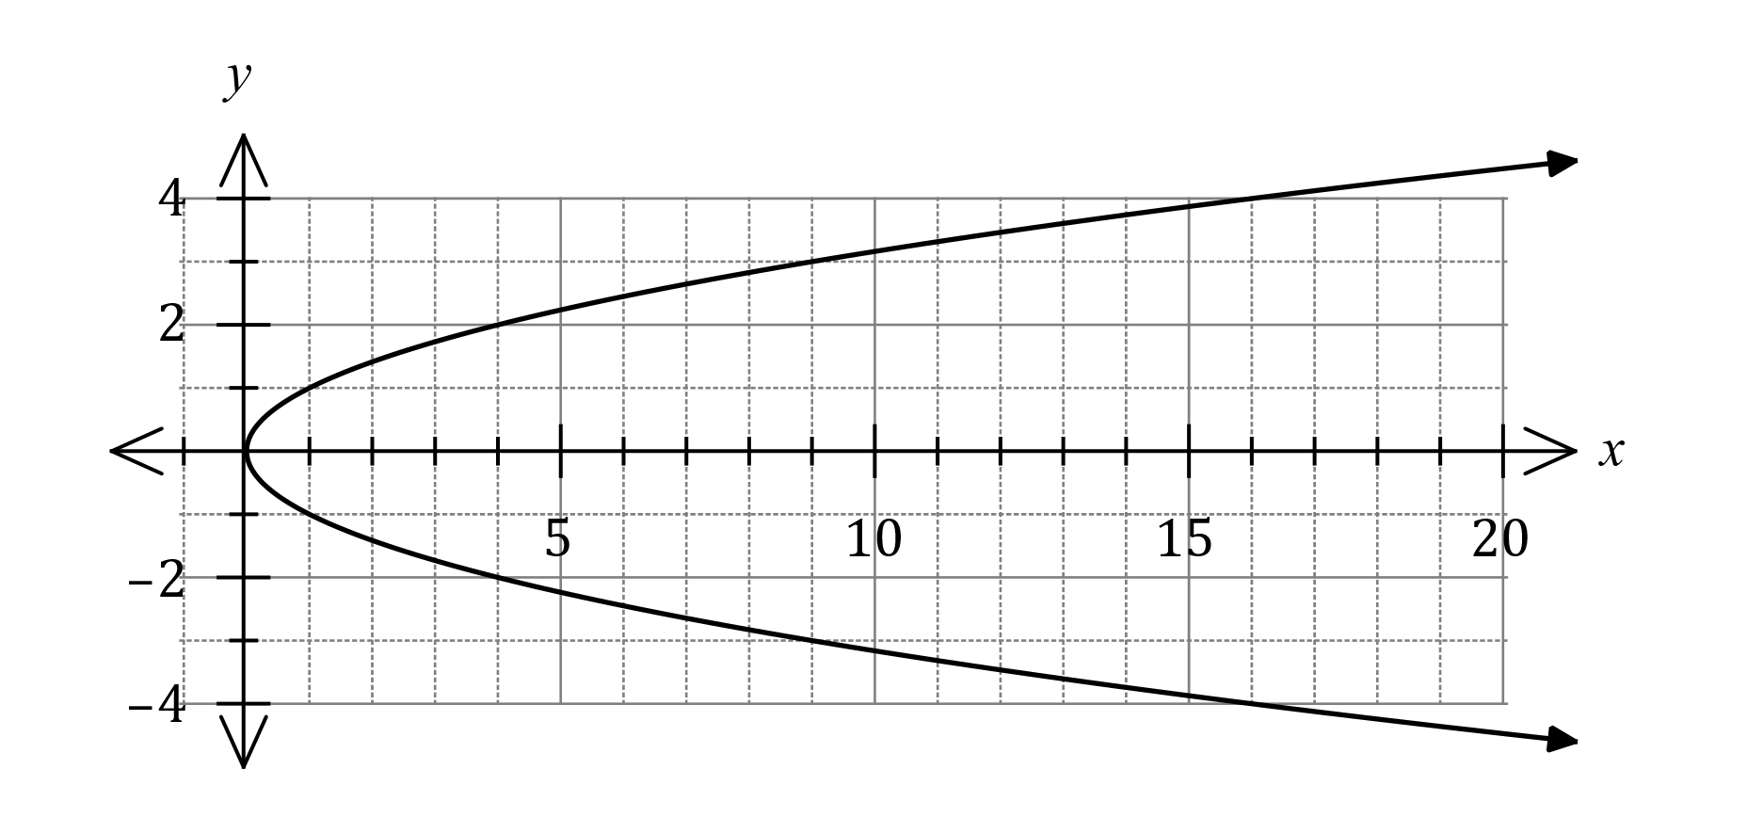

(i) State the equation of its axis of symmetry. (1 mark)

|  |
| --- |
| **Solution** |
|  |
| **Specific behaviours** |
| ✓ correct equation |

(ii) State the equation of the relationship between and . (1 mark)

|  |
| --- |
| **Solution** |
|  |
| **Specific behaviours** |
| ✓ correct equation |

(b) Points and have coordinates and respectively. Determine the equation of the circle that has diameter .

(4 marks)

|  |
| --- |
| **Solution** |
| Midpoint:  Radius:  Equation: |
| **Specific behaviours** |
| ✓ identifies midpoint as centre  ü calculates coordinates of centre  ü calculates radius or diameter  ü writes equation of circle |

Question 10 (4 marks)

The graph of is shown on the axes below.

<EFOFEX>

id:fxd{89599439-cf70-4b6d-884d-8e8ae86c2903}


FXData:

</EFOFEX>

1. Determine the coordinates of the -intercepts of the above parabola. (1 mark)

|  |
| --- |
| **Solution** |
| and . |
| **Specific behaviours** |
| ✓ correct coordinates |

(b) Determine the coordinates of the turning point. (1 mark)

|  |
| --- |
| **Solution** |
|  |
| **Specific behaviours** |
| ✓ correct coordinates |

(c) Determine the value of such that has one -intercept. (1 mark)

|  |
| --- |
| **Solution** |
|  |
| **Specific behaviours** |
| ✓ correct value |

(d) Determine the value of such that the -intercepts of are and .

(1 mark)

|  |
| --- |
| **Solution** |
|  |
| **Specific behaviours** |
| ✓ correct value |

Question 11 (5 marks)

The graphs of three functions are given below.

|  |  |  |
| --- | --- | --- |
| <EFOFEX>  id:fxd{89709625-6c49-4968-ac56-7847bca0fbb2}   FXData:   </EFOFEX> | <EFOFEX>  id:fxd{c4de7fbe-74b3-45ee-b560-87c859576e71}   FXData:   </EFOFEX> | <EFOFEX>  id:fxd{a67a2847-bf59-43d7-841a-1ba305d69625}   FXData:   </EFOFEX> |

|  |  |  |
| --- | --- | --- |
| Graph 1 | Graph 2 | Graph 3 |

(a) Match the graphs numbered above with a statement below that best describes the graph’s function.

(i) The graph whose function has a negative leading coefficient is graph __3__. (1 mark)

(ii) The graph which has degree 2 is graph __2__. (1 mark)

(iii) The graph where , as is graph __1__. (1 mark)

|  |
| --- |
| **Solution** |
| 1. Graph 3 2. Graph 2 3. Graph 1 |
| **Specific behaviours** |
| ✓ correct graph numbers |

(b) A cubic can be factorised as , where . Determine the values of and if the graph has an -intercept of 2 and a -intercept of .

(2 marks)

|  |
| --- |
| **Solution** |
|  |
| **Specific behaviours** |
| ✓ determines  ✓ determines |

Question 12 (8 marks)

Let .

(a) Sketch the graph of on the axes below. (4 marks)

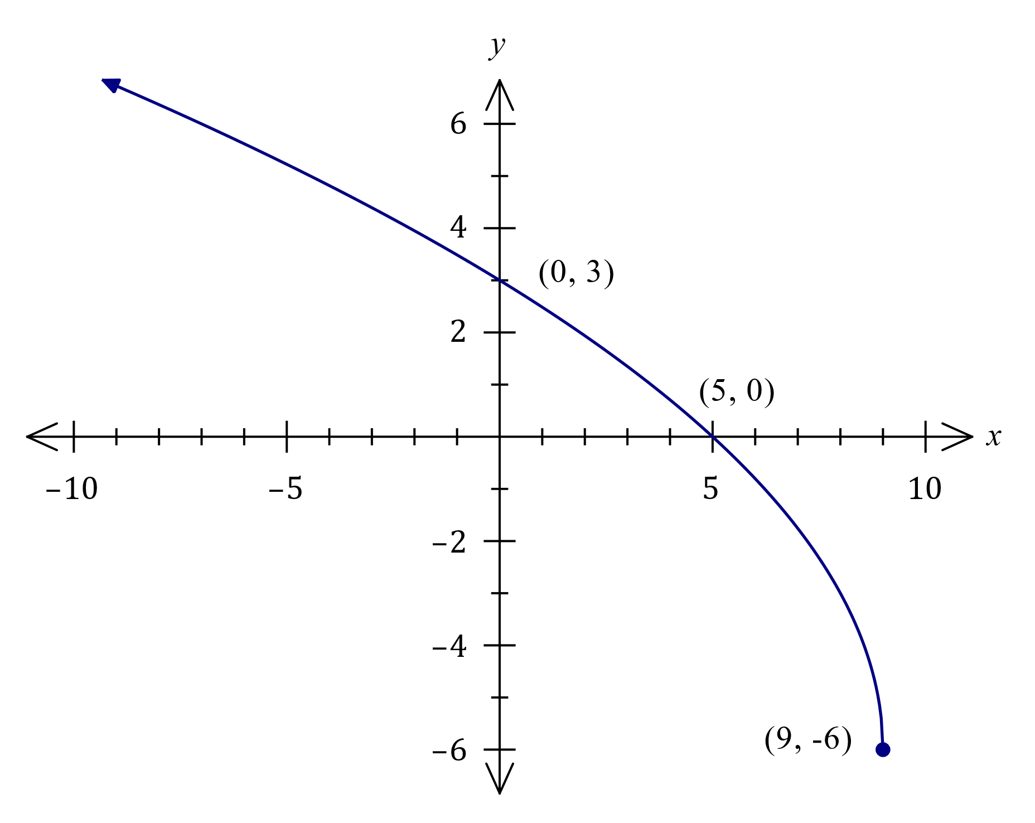

|  |
| --- |
| **Solution** |
| See graph |
| **Specific behaviours** |
| ✓ endpoint, clearly located  ü locates root  ü locates -intercept  ü smooth curve with arrow |

(b) Describe the transformation(s) required to obtain the graphs of the following functions from the graph of :

(i) . (2 marks)

|  |
| --- |
| **Solution** |
| . **Vertical dilation** of scale factor . |
| **Specific behaviours** |
| ✓ both bolded words in description  ü correct scale factor |

(ii) . (2 marks)

|  |
| --- |
| **Solution** |
| . Horizontal translation of units to the left. |
| **Specific behaviours** |
| ✓ states a translation  ü correct distance and direction |

Question 13 (8 marks)

(a) Triangle is such that cm, cm and . Determine, with justification, the length of side . (2 marks)

|  |
| --- |
| **Solution** |
|  |
| **Specific behaviours** |
| ✓ clearly shows use of cosine rule  ü correct length |

(b) Triangle is such that cm, cm and . Determine all possible areas of this triangle.

(6 marks)

|  |
| --- |
| **Solution** |
| First solution:  Second solution:  Areas are and . |
| **Specific behaviours** |
| ✓ shows use of sine rule  ü calculates one value for  ü derives and shows use of area formula  ü calculates one correct area  ü calculates second set of values for and  ü calculates second area |

Question 14 (8 marks)

(a) Let , where and are constants. The graph of has an axis of symmetry with equation and an axis intercept at .

(i) State the value of the constant . (1 mark)

|  |
| --- |
| **Solution** |
| is the -intercept: . |
| **Specific behaviours** |
| ✓ correct value |

(ii) Determine the value of the constant . (2 marks)

|  |
| --- |
| **Solution** |
| Axis of symmetry has equation : |
| **Specific behaviours** |
| ✓ indicates appropriate method  ü calculates value |

(b) Let . Determine

(i) the coordinates of the turning point of the graph of . (1 mark)

|  |
| --- |
| **Solution** |
| Turning point is at . |
| **Specific behaviours** |
| ✓ correct coordinates |

(ii) the domain and range of . (2 marks)

|  |
| --- |
| **Solution** |
| Domain:  Range: . |
| **Specific behaviours** |
| ✓ states domain  ü states range |

(iii) the coordinates of the turning point of the graph of . (2 marks)

|  |
| --- |
| **Solution** |
| Graph has been translated units right and units upwards and so new turning point at . |
| **Specific behaviours** |
| ✓ indicates correct use of one translation  ü correct coordinates |

Question 15 (9 marks)

The loudness of sound, in decibels, emitted by a machine minutes after it is switched on can be modelled by

(a) Determine the initial loudness emitted by the machine. (1 mark)

|  |
| --- |
| **Solution** |
|  |
| **Specific behaviours** |
| ✓ correct value |

(b) Draw the graph of against on the axes below for the first minutes. (3 marks)

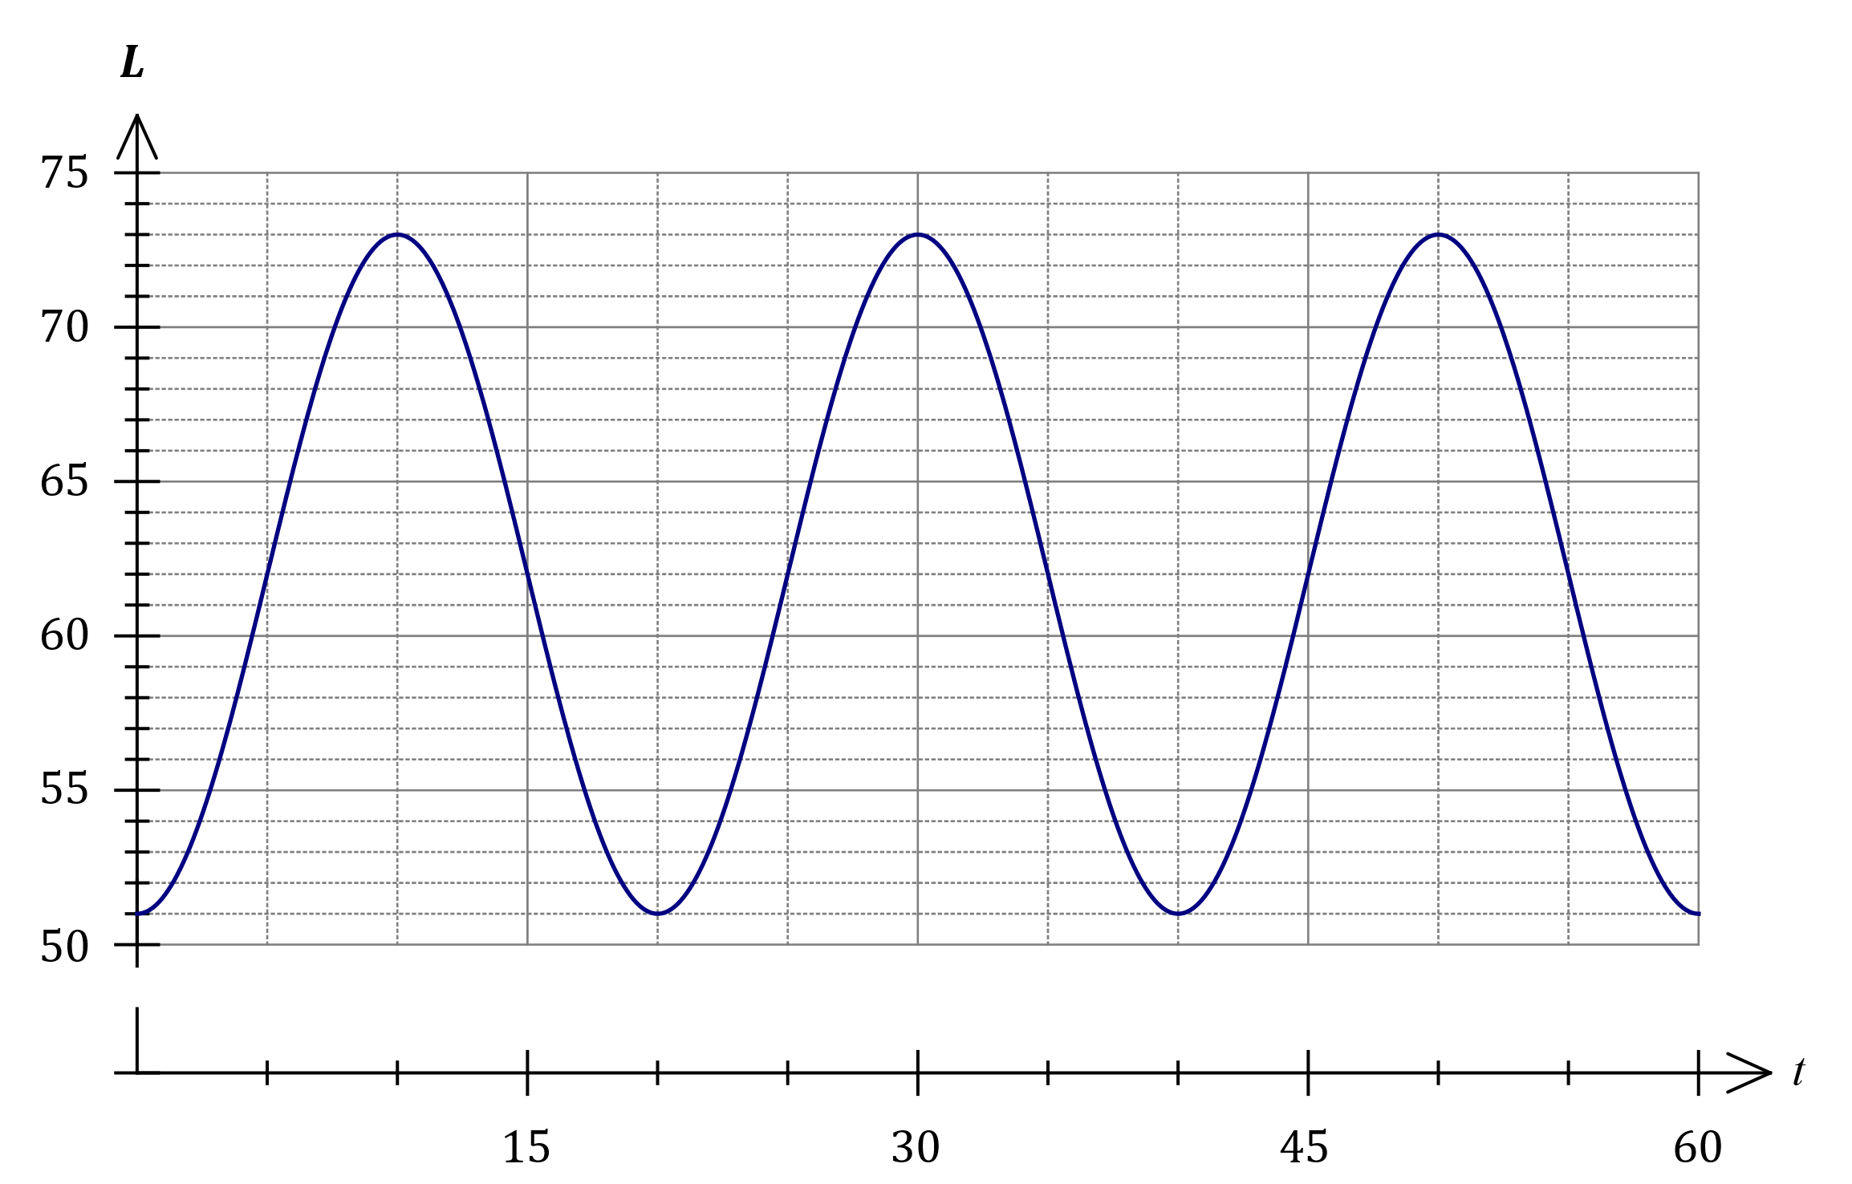

|  |
| --- |
| **Solution** |
| See graph |
| **Specific behaviours** |
| ✓ locates all maxima  ü locates all minima  ü smooth trig. curve |

(c) State the maximum loudness emitted by the machine and the time this maximum was first reached.

|  |
| --- |
| **Solution** |
| when . |
| **Specific behaviours** |
| ✓ correct maximum  ü correct time |

(2 marks)

(d) A health and safety inspector can deem a machine unserviceable if the loudness it emits exceeds dB for more than minutes in any hour that it is running. Determine, with justification, whether this machine could be deemed unserviceable.

(3 marks)

|  |
| --- |
| **Solution** |
| Exceeds value for during first cycle.  minutes per hour - and so machine could not be deemed unserviceable. |
| **Specific behaviours** |
| ✓ identifies interval endpoints  ü calculates minutes per hour  ü uses calculations to draw conclusion |

Question 16 (5 marks)

The diagram below shows two unit circles, A and B, with two angles, and marked in each one respectively. Both angles are in radians.

A B

|  |  |
| --- | --- |
| <EFOFEX>  id:fxd{cb94d7c5-0fe0-4172-8d0b-3a9a6f9e9b2f}   FXData:   </EFOFEX> | <EFOFEX>  id:fxd{80024016-8a05-4c44-a8bf-f2f6a09e38ce}   FXData:   </EFOFEX> |

(a) On unit circle A, draw in angle such that sin sin , where . (1 mark)

|  |
| --- |
| **Solution** |
|  |
| **Specific behaviours** |
| ✓ Draws angle in quadrant 2 with the same y-coordinate as |
|  |

(b) On unit circle B, draw in angle such that cos cos , where . (1 mark)

|  |
| --- |
| **Solution** |
|  |
| **Specific behaviours** |
| ✓ Draws angle in quadrant 1 with the opposite coordinates as |
|  |

(c) Use an appropriate trigonometric expansion to show cos . (3 marks)

|  |
| --- |
| **Solution** |
|  |
| **Specific behaviours** |
| ✓ identifies 75 as the sum of two angles  ü shows use of the angle sum identity  ü substitutes in the correct exact values |



Question 17 (5 marks)

A chess club has members, of which are beginners, are intermediate and the rest are advanced. The club has to select a group of members at random to assist with a regional tournament.

(a) Determine the number of different groups that can be selected. (2 marks)

|  |
| --- |
| **Solution** |
|  |
| **Specific behaviours** |
| ✓ correctly uses any combination notation  ü correct number |

(b) Determine the number of different groups that can be selected which contain at least intermediate members. (2 marks)

|  |
| --- |
| **Solution** |
| Choose intermediates:  Choose intermediates:  Total: |
| **Specific behaviours** |
| ✓ number with intermediates  ü number with intermediates and total |

(c) The number of different groups that could be selected was decided to be calculated using the following calculation:

Describe how the group members were selected. (1 mark)

|  |
| --- |
| **Solution** |
| The group has only one advanced member  and the rest are either beginner or intermediate. |
| **Specific behaviours** |
| ✓ states exactly one advanced member |

Question 18 (8 marks)

The cross section of a roof structure is shown below. All lengths are given in meters.

<EFOFEX>

id:fxd{4a8f5e11-2a8d-43fc-9c1e-4bb6f2b57aa8}


FXData:

</EFOFEX>

1. Determine the horizontal length of the overhang, , correct to two decimal places.

(2 marks)

|  |
| --- |
| **Solution** |
|  |
| **Specific behaviours** |
| ✓ uses trigonometric ratio correctly  ✓ determines  correct to two decimal places |

Two roofing companies are approached to give a quote to cover the roof in corrugated iron. The cost of the first company is shown on the graph below, where is the cost in dollars.

<EFOFEX>

id:fxd{bf4283ec-fe80-4e15-8d4d-6155eed2e461}


FXData:


</EFOFEX>

|  |
| --- |
| **Solution** |
| See graph |
| **Specific behaviours** |
| ✓ correct vertical intercept  ü correct gradient of the line |

1. (i) Give a reason why the graph on the previous page, demonstrates that the cost of

roofing, , is directly proportional to the roof area, .

(1 mark)

|  |
| --- |
| **Solution** |
| The graph is linear with a positive gradient  and it passes through the origin |
| **Specific behaviours** |
| ✓ correct reason |

(ii) Determine a rule for the cost of roofing, , in terms of the roof area, . (1 mark)

|  |
| --- |
| **Solution** |
|  |
| **Specific behaviours** |
| ✓ determines the rule for the cost |

A second company quotes $40 per square metre, with a delivery and installation charge of $750.

1. (i) On the axes opposite, draw a graph representing the cost quoted by the second company.

(2 marks)

(ii) Explain why the cost, , quoted by the second company is not directly proportional to the roof area, .

(1 mark)

|  |
| --- |
| **Solution** |
| The graph does not pass through the origin  OR  There is a fixed cost |
| **Specific behaviours** |
| ✓ correct reason |

During hot weather the interior of corrugated iron roofs heat up.

Whirlybirds, as shown, are used to extract hot air.

Whirlybirds are installed on the roof on the opposite page.

It is calculated that for this roof, one whirlybird working at

maximum efficiency would extract 150 m3 of hot air an hour.

However, as more whirlybirds are added, each one becomes

less effective. The amount of hot air each whirlybird extracts

is inversely proportional to the number of whirlybirds.

1. Determine a rule for the amount of hot air extracted by each whirlybird, m3 per hour, in terms of the number of whirlybirds installed, .

(1 mark)

|  |
| --- |
| **Solution** |
|  |
| **Specific behaviours** |
| ✓ determines correct rule |

Question 19 (6 marks)

The diagram below, represents the graph of , where .

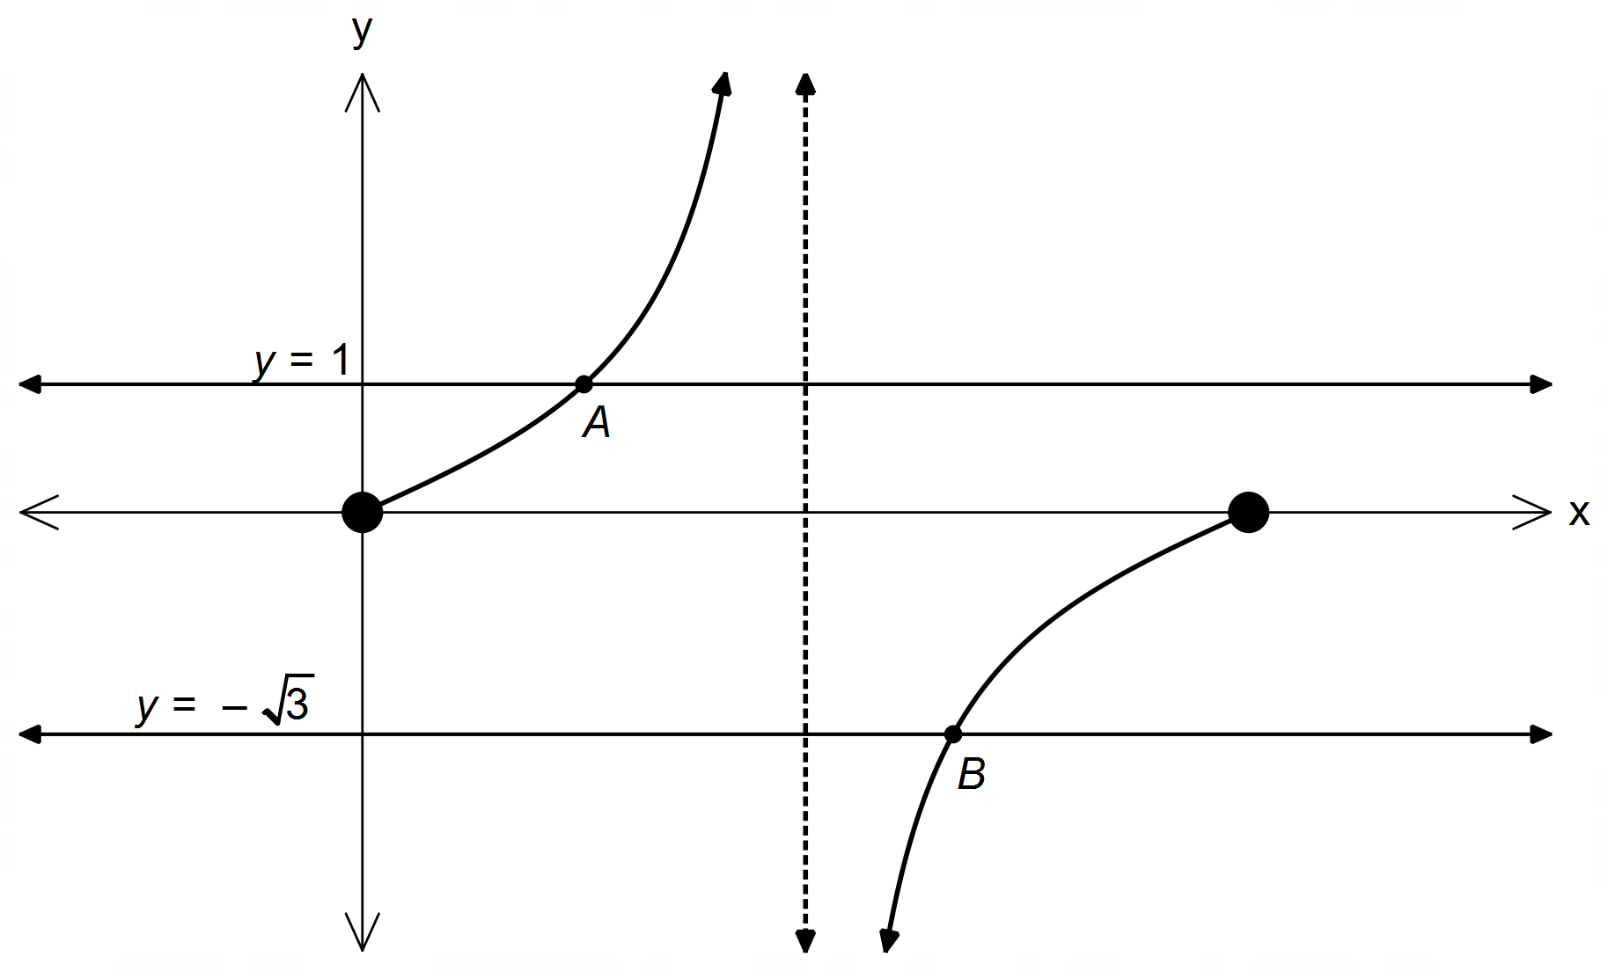

1. State the equation for the asymptote in this interval. (1 mark)

|  |
| --- |
| **Solution** |
|  |
| **Specific behaviours** |
| ✓ correct asymptote |

1. Determine the exact coordinates of point A and point B. (3 marks)

|  |
| --- |
| **Solution** |
| Point  Reference angle for Point B = |
| **Specific behaviours** |
| ✓ correct coordinates for A  ✓ correct reference angle for B  ✓ correct coordinates for B |

1. Consider the graph below, where has undergone a transformation.

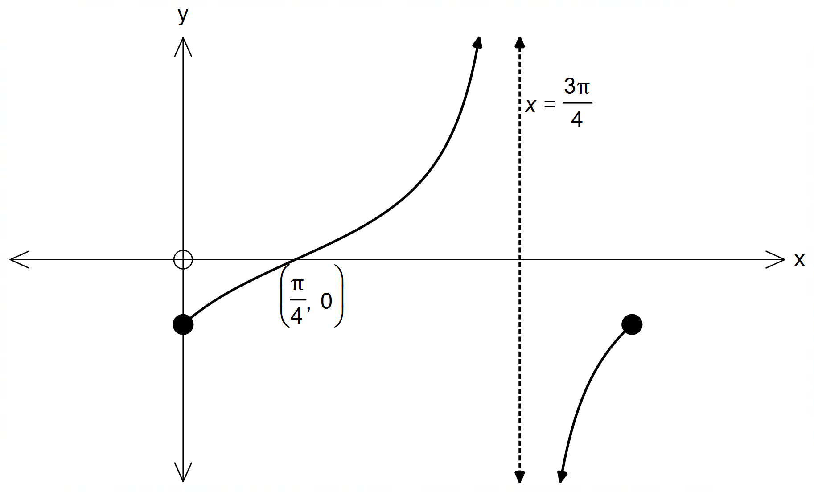

1. State the phase change where . (1 mark)

|  |
| --- |
| **Solution** |
| OR  to the right |
| **Specific behaviours** |
| ✓ correct phase change  OR value for c |

1. State the period of . (1 mark)

|  |
| --- |
| **Solution** |
| radians |
| **Specific behaviours** |
| ✓ correct period |

Question 20 (6 marks)

1. Solve (1 mark)

|  |
| --- |
| **Solution** |
|  |
| **Specific behaviours** |
| ✓ correctly states both values |

1. Using the Pythagorean identity, , determine a simplified expression for in terms of powers of and a constant term.

(2 marks)

|  |
| --- |
| **Solution** |
|  |
| **Specific behaviours** |
| ✓ substitutes  ✓ correctly writes a simplified expression in  terms of |

1. Using your response to parts (a) and (b), or otherwise, solve the following equation over the given domain.

for (3 marks)

|  |
| --- |
| **Solution** |
|  |
| **Specific behaviours** |
| ✓ clearly shows use of parts (a) and (b)  Or another correct approach  ✓ states both possible equations involving  ✓ solves over the given domain |
|  |

Question 21 (7 marks)

The equation of a parabola is .

(a) Sketch the parabola on the axes below. (3 marks)

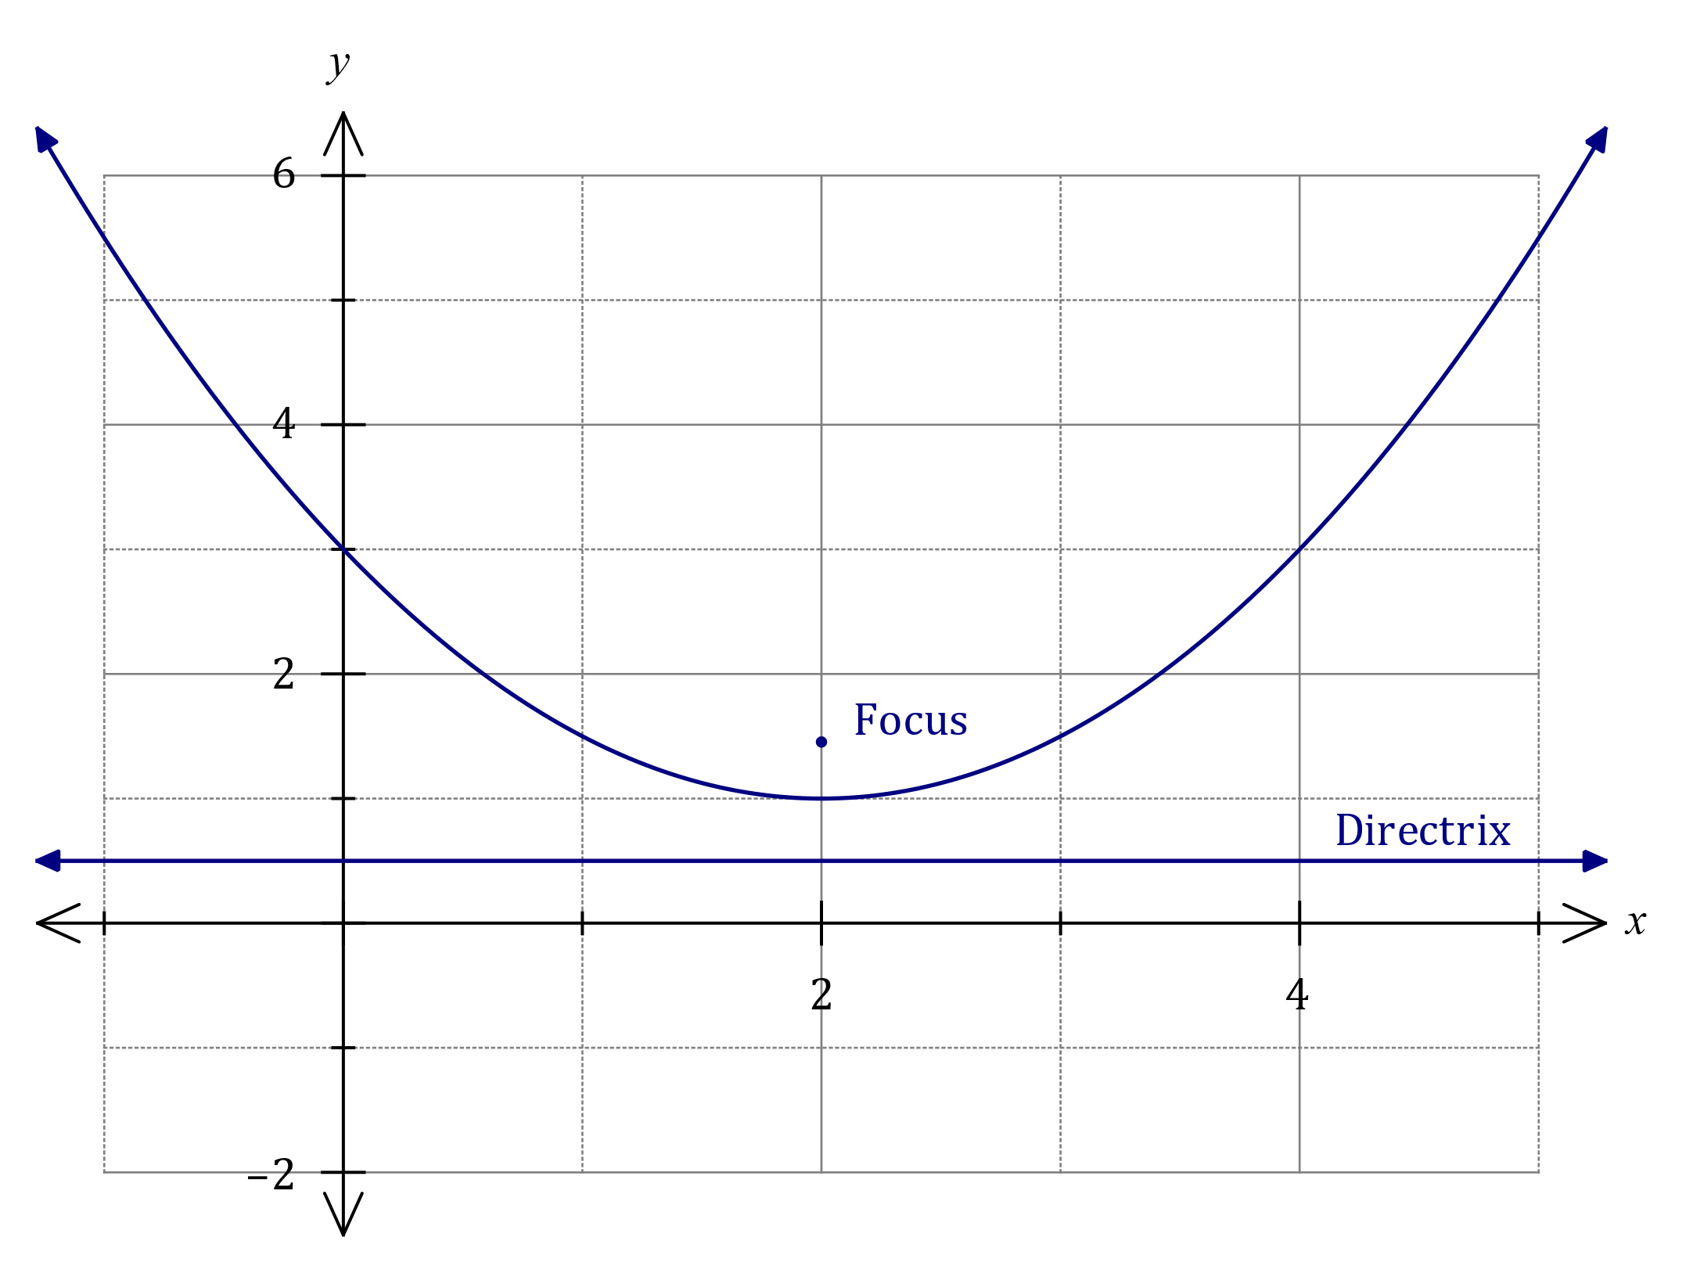

|  |
| --- |
| **Solution** |
| See graph |
| **Specific behaviours** |
| ✓ correct turning point  ü correct -intercept  ü smooth symmetrical curve |

All parabolas have a focal point and a directrix. For a parabola with equation , the focal point is at and the equation of the directrix is , where and are constants.

(b) Determine the focal point and directrix for this parabola and add them, with labels, to your sketch above. (4 marks)

|  |
| --- |
| **Solution** |
| From graph, turning point at . Hence  Focal point: and directrix: . |
| **Specific behaviours** |
| ✓ determines and  ü indicates values of all constants  ü plots focus  ü draws directrix |

Question 22 (7 marks)

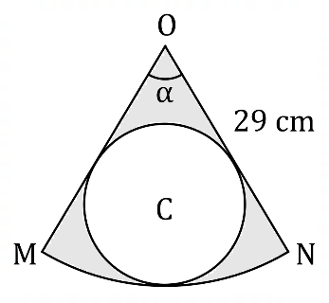The diagram shows sector of a circle  
centre of radius cm and .

Circle is inside the sector and just  
touches and arc .

(a) Determine the area of sector . (2 marks)

|  |
| --- |
| **Solution** |
|  |
| **Specific behaviours** |
| ✓ indicates suitable method  ü calculates area |

(b) Show that the radius of circle is cm, correct to one decimal place. (3 marks)

|  |
| --- |
| **Solution** |
| Extend sector sides to form isosceles triangle: |
| **Specific behaviours** |
| ✓ forms isosceles triangle, shows angles  ü calculates  ü calculates radius |

(c) Determine the area of the shaded region, inside sector but outside circle .

(2 marks)

|  |
| --- |
| **Solution** |
| Shaded area |
| **Specific behaviours** |
| ✓ calculates area of circle  ü calculates shaded area, with units |

Question 23 (6 marks)

The equation has two solutions, where and and are constants.

The graph of cuts the -axis at , , and at one other point.

Determine the value(s) of the constant , rounded to decimal places. Explain your reasoning.

|  |
| --- |
| **Solution** |
| Use roots to solve for and :  Solving simultaneously with CAS gives and .    For two solutions, must equal the local maximum or equal the local minimum of - found using CAS.  Local maximum is  Local minimum is  Hence or . |
| **Specific behaviours** |
| ✓ equates  ü equates  ü solves equation for  ü solves equation for  ü states value of local minimum, maximum  ü correct solutions for |

© 2021 WA Exam Papers. Willetton Senior High School has a non-exclusive licence to copy and communicate this document for non-commercial, educational use within the school. No other copying, communication or use is permitted without the express written permission of WA Exam Papers. SN115-172-4.